

Practices for Secure Software Report

Table of Contents
Document Revision History 3
Client 3
Instructions 3
Developer 4
1. Algorithm Cipher 4
2. Certificate Generation 4
3. Deploy Cipher 4
4. Secure Communications 4
5. Secondary Testing 4
6. Functional Testing 4
7. Summary 4
8. Industry Standard Best Practices 4

Document Revision History

Version | Date | Author | Comments
1.0 | 10/14/2026 | Lucas Goodykoontz | Initial submission

Client



Instructions

Submit this completed practices for secure software report. Replace the bracketed text with the relevant information. You must document your process for writing secure communications and refactoring code that complies with software security testing protocols.

- Respond to the steps outlined below and include your findings.
- Respond using your own words. You may also choose to include images or supporting materials. If you include them, make certain to insert them in all the relevant locations in the document.
- Refer to the Project Two Guidelines and Rubric for more detailed instructions about each section of the template.

Developer
Lucas Goodykoontz

Algorithm Cipher

I recommend SHA-256 for Artemis Financial's file verification step. Strictly speaking, SHA-256 is a cryptographic hash function rather than a cipher: it does not encrypt data so that it can be decrypted later. It takes input of any size and produces a fixed 256-bit digest (64 hexadecimal characters), and it is a one-way function. That is what a checksum needs. If even one bit of a transferred file changes, the digest changes completely, so Artemis and its clients can compare the checksum computed on receipt with the one published by the server and know whether the data arrived intact.
SHA-256 belongs to the SHA-2 family defined by NIST in FIPS 180-4. Internally it splits the message into 512-bit blocks and runs each one through 64 rounds of mixing in a Merkle–Damgård construction, carrying a 256-bit internal state from block to block. The 256-bit output gives about 128 bits of collision resistance, which is far beyond what any attacker can brute force today. Other hash options were ruled out. MD5 (128-bit) and SHA-1 (160-bit) both have practical collision attacks: MD5 was broken in 2004 and Google demonstrated a real SHA-1 collision in 2017. SHA-512 and SHA-3 would also be acceptable, but SHA-256 is the industry default and ships in Java's MessageDigest class, so no additional library or dependency is needed. That matters for an application whose dependency scan already shows risk in third-party code.
A hash function uses no key and no random numbers. The same input always produces the same output, which is exactly why it works for verification. Randomness and keys come into play in the layer around it, the HTTPS connection. The self-signed certificate I generated uses a 2048-bit RSA key pair, which is asymmetric (non-symmetric): the public key is shared in the certificate and the private key never leaves the server keystore. During the TLS handshake the asymmetric keys authenticate the server, and both sides use cryptographically secure random numbers to agree on a one-time session key. The rest of the session is encrypted with a fast symmetric cipher such as AES-GCM, where both sides hold the same key. The certificate itself is signed with SHA256withRSA, so SHA-256 shows up at that layer too. Because a plain hash only proves integrity if the checksum itself comes from a trusted source, delivering it over HTTPS is what keeps an attacker from swapping both the file and its checksum. If Artemis later needs to verify files outside the web session, the natural next step would be HMAC-SHA256, which adds a secret key to the hash.
Encryption has moved forward each time computing power caught up with an algorithm. DES became the U.S. standard in 1977, but its 56-bit key was brute-forced by 1998, and it was replaced by Triple DES and then AES (Rijndael) in 2001. Public-key cryptography arrived with Diffie-Hellman in 1976 and RSA in 1977, which made secure communication between strangers on the internet possible. Hash functions followed the same pattern: MD5 gave way to SHA-1, which gave way to SHA-2 (2001), with SHA-3 (Keccak) standardized in 2015 as a structurally different backup. Today the main concern is quantum computing. In August 2024 NIST published its first post-quantum standards (FIPS 203, 204 and 205) to eventually replace RSA and elliptic-curve key exchange. SHA-256 holds up comparatively well, because quantum search only reduces its effective strength to about 128 bits, which is still considered secure. That makes it a sound choice for Artemis now and for the foreseeable future.

Certificate Generation
Insert a screenshot below of the CER file.

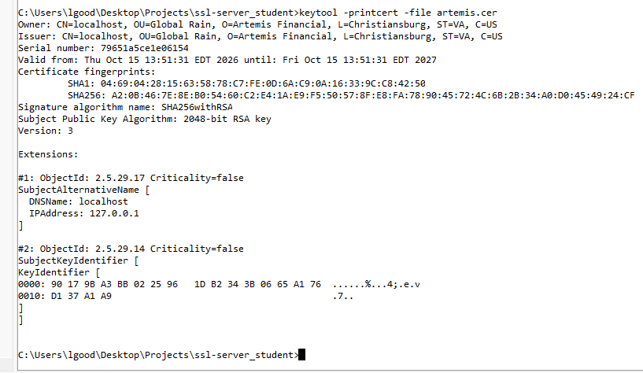
keytool -printcert output for the exported artemis.cer certificate
I generated a self-signed certificate with the Java keytool and stored it as a PKCS12 keystore in src/main/resources, then exported the public certificate as a CER file:
keytool -genkeypair -alias artemis -keyalg RSA -keysize 2048 -sigalg SHA256withRSA -validity 365 -keystore keystore.p12 -storetype PKCS12 -dname "CN=localhost, OU=Global Rain, O=Artemis Financial, L=Christiansburg, ST=VA, C=US" -ext "SAN=dns:localhost,ip:127.0.0.1"
keytool -exportcert -alias artemis -keystore keystore.p12 -file artemis.cer -rfc
keytool -printcert -file artemis.cer

Deploy Cipher
Insert a screenshot below of the checksum verification.

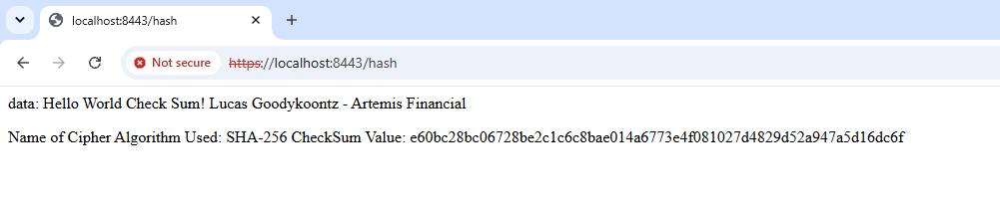
SHA-256 checksum verification at https://localhost:8443/hash
I added a ServerController class with a GET /hash route. It takes the unique data string "Hello World Check Sum! Lucas Goodykoontz - Artemis Financial", hashes it with MessageDigest.getInstance("SHA-256") using an explicit UTF-8 encoding, converts the digest to hexadecimal, and returns the data, the algorithm name and the checksum value. The expected checksum is e60bc28bc06728be2c1c6c8bae014a6773e4f081027d4829d52a947a5d16dc6f.

Secure Communications
Insert a screenshot below of the web browser that shows a secure webpage.

Application served over HTTPS on port 8443
In application.properties I replaced the placeholder entries so the embedded Tomcat server only listens over TLS on port 8443: server.ssl.enabled=true, server.ssl.key-alias=artemis, server.ssl.key-store=classpath:keystore.p12 and server.ssl.key-store-type=PKCS12, plus the keystore password. Because the certificate is self-signed, the browser warns on the first visit. After accepting the certificate, https://localhost:8443/hash loads over an encrypted TLS connection. Chrome still labels the page "Not secure" because no trusted certificate authority signed the certificate. That label is about trust in the certificate, not the encryption, and a CA-issued certificate would remove it in production.

Secondary Testing
Insert screenshots below of the refactored code executed without errors and the dependency-check report.

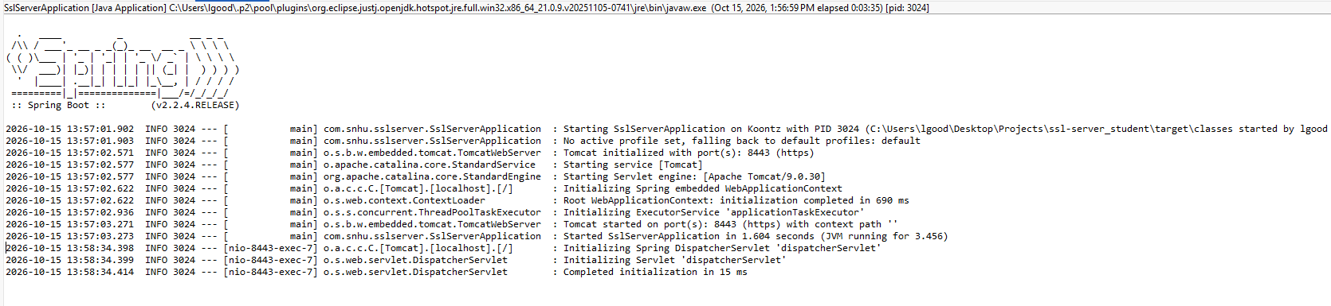
Refactored application running without errors (Tomcat started on port 8443, https)
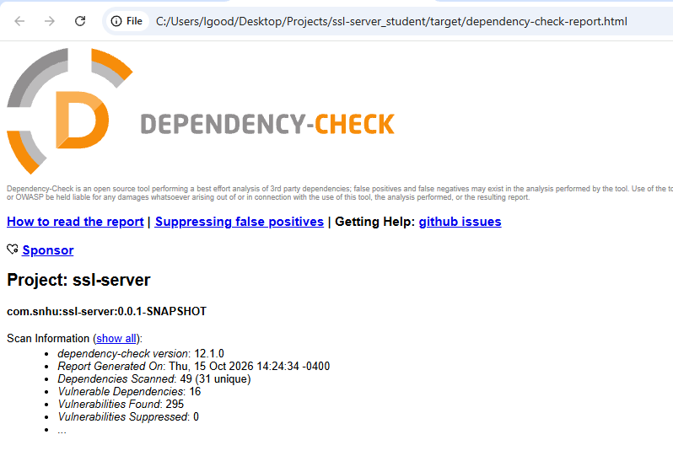
Dependency-check report header (version 12.1.0)
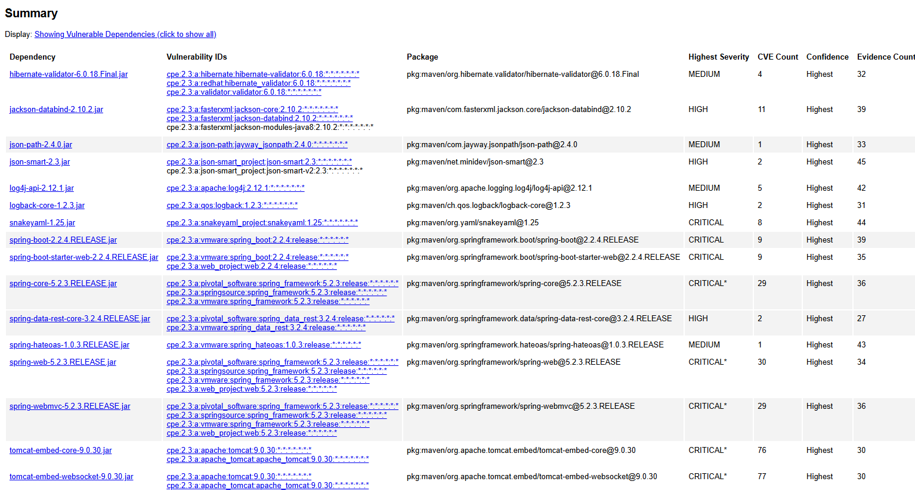
Dependency-check summary of vulnerable dependencies
I reran the OWASP dependency-check plugin against the refactored project. To get the scan working I made three changes to the pom. I upgraded the plugin from 5.3.0 to 12.1.0, because the old version depended on NVD data feeds that have since been retired. I passed my NVD API key in through a property reference (${nvd.api.key}), so the key stays in my Maven settings.xml and never ends up in the project files. I also disabled the Sonatype OSS Index analyzer, which now requires separate credentials, and relied on the NVD database for the scan.
The scan covered 49 dependencies (31 unique) and flagged 16 vulnerable dependencies with 295 known vulnerabilities. Every one of them is a library that came with the original code base through spring-boot-starter-web and spring-boot-starter-data-rest: Spring Framework 5.2.3, embedded Tomcat 9.0.30, Jackson, SnakeYAML, Logback, Hibernate Validator, json-path/json-smart and Spring HATEOAS. The refactoring did not add any dependencies, because the checksum code relies only on java.security.MessageDigest from the JDK, so my changes introduced no new vulnerabilities. The existing findings would be fixed by upgrading Spring Boot, which I recommend as a follow-up below.

Functional Testing
Insert a screenshot below of the refactored code executed without errors.

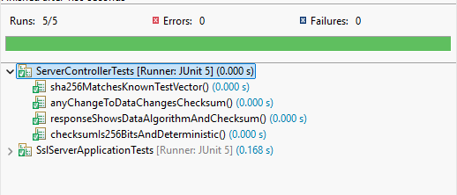
JUnit results: all tests passed
Refactored application running without errors
In my manual review I looked for syntax, logic and security problems in the new code. I made sure the algorithm is a NIST-approved hash rather than MD5 or SHA-1, the character encoding is fixed so the checksum is the same on every platform, and the NoSuchAlgorithmException is caught and returned as a generic 500 error instead of a stack trace. The route takes no user input, so there is nothing to inject into, and the data is still HTML-escaped before it is written into the response in case the source changes later. I also added JUnit tests (ServerControllerTests) that check the NIST test vector for "abc", confirm that the checksum is 256 bits and deterministic, and confirm that changing a single character changes the checksum. The application compiles, the tests pass, and the server starts without errors.

Summary

I refactored the Artemis Financial application in three places. I added a checksum route to the controller layer, configured the server for HTTPS with a self-signed certificate, and updated the dependency-check plugin so the security scan still runs against the current NVD data. Looking at the vulnerability assessment process flow diagram, the work falls mainly under cryptography and client/server communication. On the cryptography side, I chose and implemented a current, NIST-approved hash algorithm instead of writing custom crypto or using a broken one. On the client/server side, all traffic now goes over TLS, so data and checksums can't be read or altered in transit. The changes also touch code error handling (the hash method fails securely without leaking internal details), input validation and output encoding (no user-controlled input, and escaped output), and code quality (unit tests that pin the hash to a known test vector).
I added security in layers, so that no single control carries all the weight. The first layer is integrity: the SHA-256 checksum lets a client detect any change to the data. The second layer is confidentiality and authenticity: HTTPS encrypts the connection and ties it to the server's certificate, which also protects the checksum itself from being swapped. The third layer is verification: unit tests, a manual code review, and a secondary dependency-check scan to confirm that the refactor didn't open new holes. At each step I ran the code, checked the result, and fixed anything that came up before moving on, following the iterate-and-retest loop the assessment process calls for.

Industry Standard Best Practices

I relied on established standards rather than inventing my own. The hash comes from NIST FIPS 180-4 and is implemented by the JDK's own MessageDigest class, following the OWASP guidance to use vetted cryptographic libraries and avoid deprecated algorithms (cryptographic failures are A02 on the OWASP Top 10). I kept the existing application's security intact by not adding any third-party dependencies, fixing the character encoding, failing securely instead of exposing stack traces, encoding output, and running the OWASP dependency-check again to make sure the scan results did not get worse. I also kept the NVD API key out of the project by referencing it from my Maven settings rather than hardcoding it in the pom. The keystore uses the PKCS12 format with a 2048-bit RSA key and a SHA-256 signature, which matches current recommendations. There are two items I would flag for a production release. First, the keystore password is in application.properties for this assignment, but in production it should come from an environment variable or a secrets manager. Second, the self-signed certificate should be replaced with one issued by a trusted certificate authority, and Spring Boot 2.2.4 should be upgraded, because every finding in the dependency-check report comes from the libraries it brings in.
For a company like Artemis Financial, following these practices is about more than passing a scan. Artemis handles clients' savings, retirement, investment and insurance information, which is exactly the kind of data attackers target and regulators protect. The FTC Safeguards Rule under the Gramm-Leach-Bliley Act requires financial firms to protect customer information, including encrypting it in transit. A breach would bring direct costs from incident response and possible penalties, but the bigger loss would be client trust, which a financial planning firm depends on. Building security into the code from the start is also much cheaper than fixing it after something goes wrong, and it fits Global Rain's view that security is everyone's responsibility.

